**LG WHS76UW2 Water Dispenser**

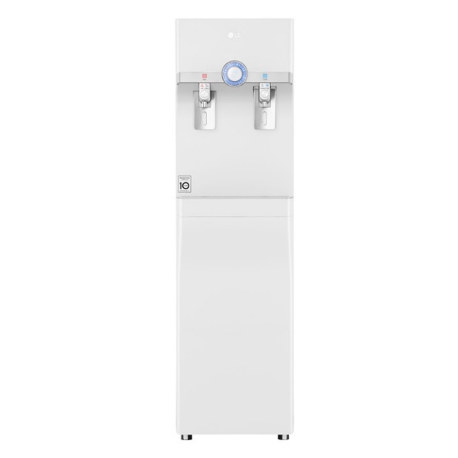

|  |  |
| --- | --- |
| **Type:** | Floor Standing |
| **Water Supply(l):** | 16 |
| **Weight(kg):** | 32 |
| **Unit Dimensions(H*W*L)mm:** | 360 x 469 x 1278 |
| **Power Supply:** | 230-240W |
| **Filter Stages:** | 4 |